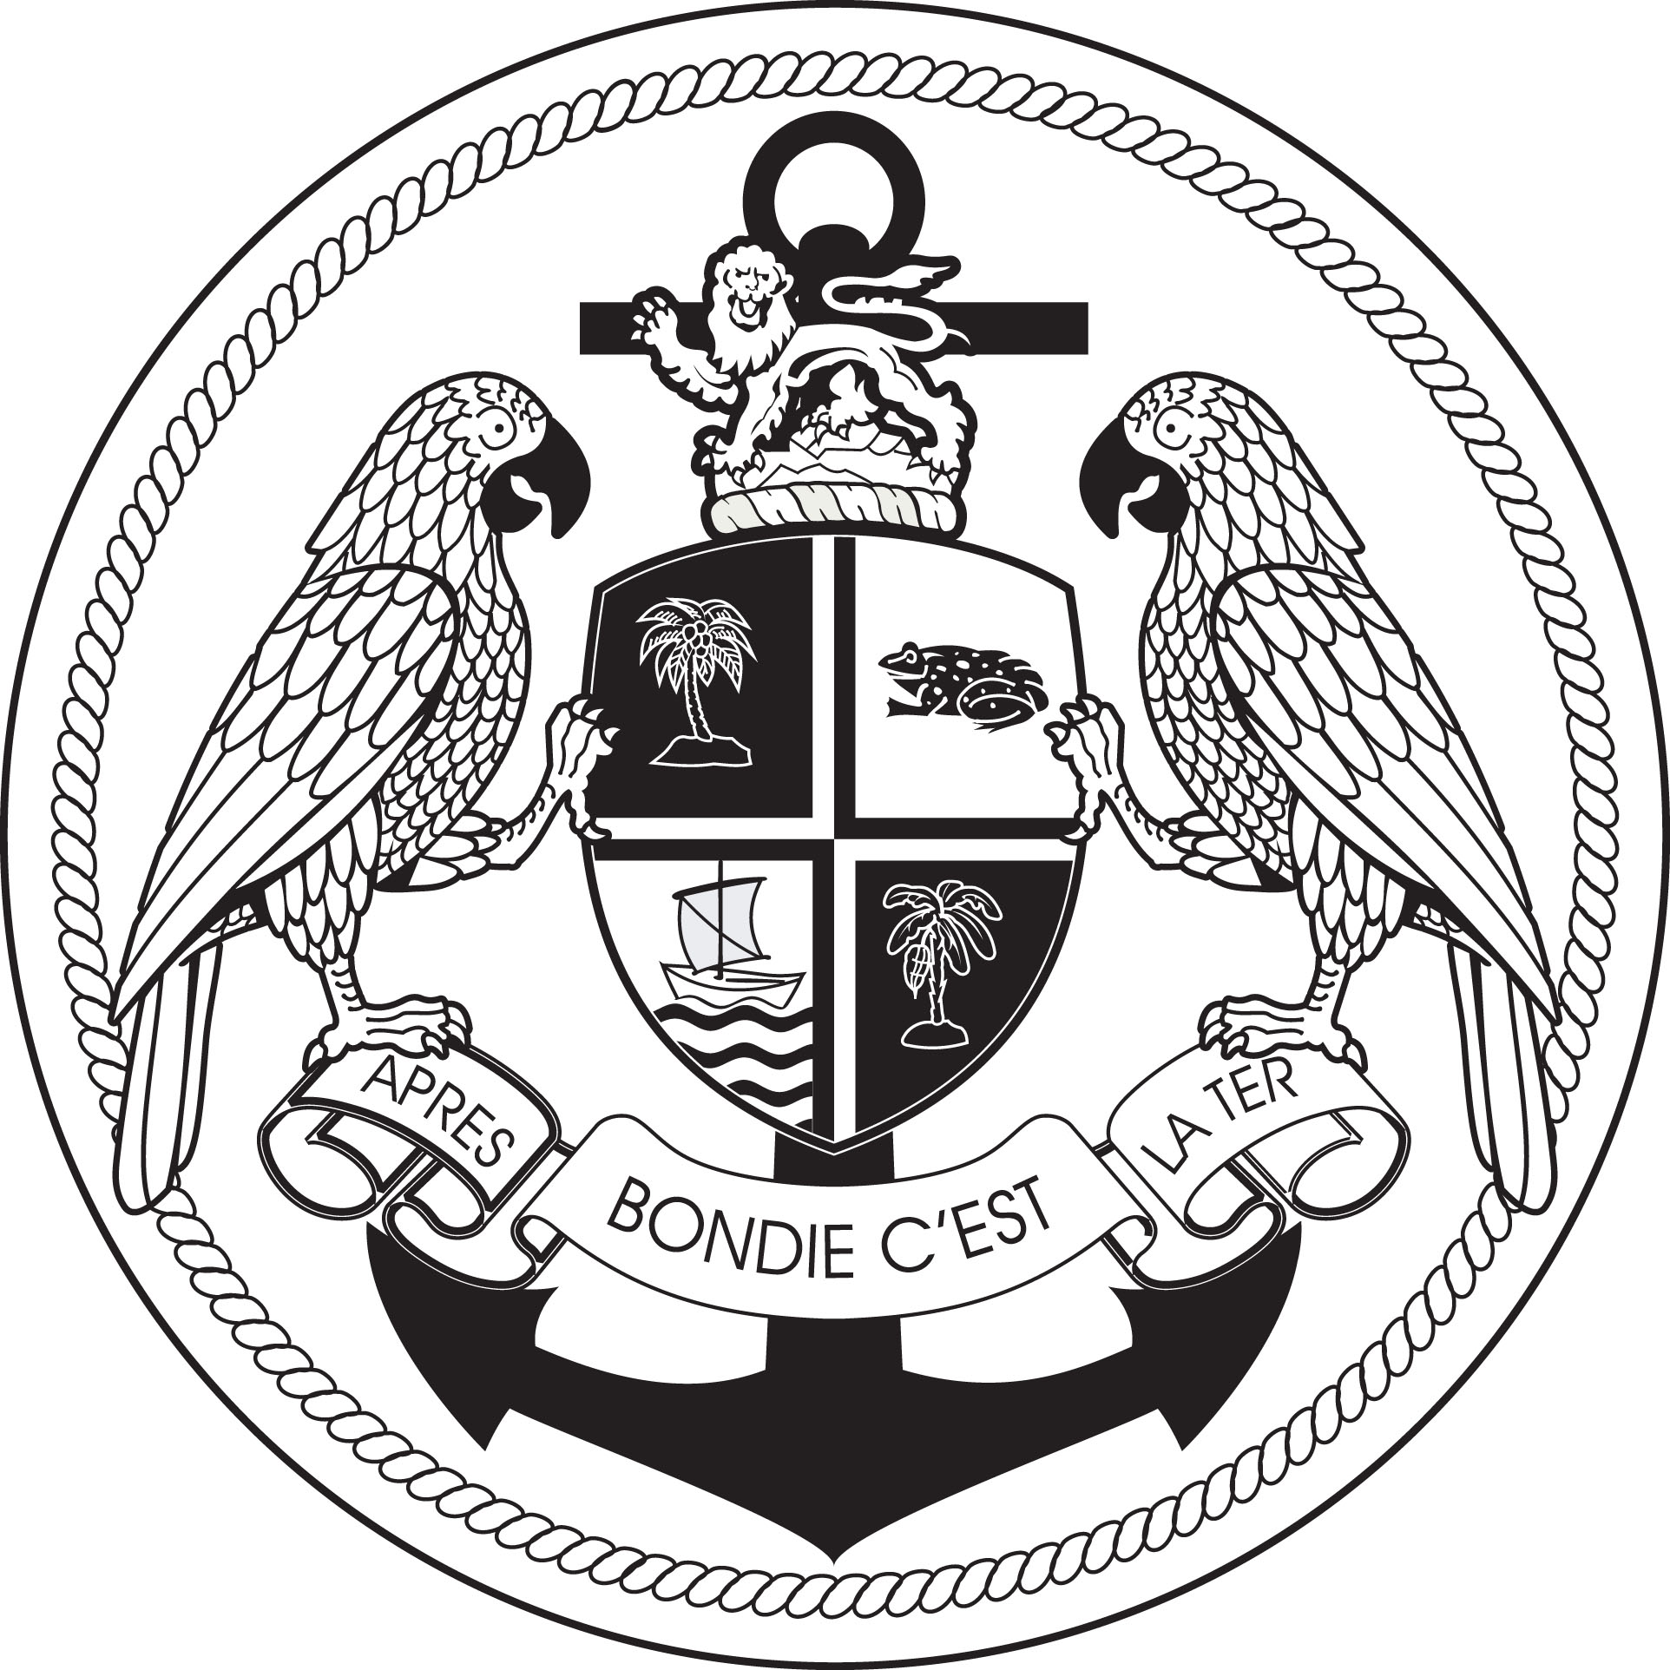
COMMONWEALTH OF DOMINICA MARITIME ADMINISTRATION
Vessel Registration Request Form
To request acceptance of a vessel for registration under the Commonwealth of Dominica flag please complete the below table and submit this form to registration@dominica-registry.com. Upon receipt of this document our team will research and assess the history of the vessel to custom tailor your registration needs.
Vessel’s Current Name and Intended Name (to check availability)
Vessel Type
IMO Number
Build Date
Intended Trading Area
Intended Classification Society
Intended Owning and Operating Company with Company IMO number
Gross Tonnage
Net Tonnage

If there are any special requests or requirements for the registration of this vessel, please state in the box below so we may better serve your needs.

